PR5087 Interface to Oracle BEE

Functional Design Narrative
The following file format is required to provide “Time” transactions imported into the Oracle BEE Tables.

Record Key (as defined below)
OEN = Person Oracle Employee Number
LEN = Person DFF Attribute1 Legacy Employee No. (field maintained on Oracle Person Record)

Project and Task combinations will be validated against the Oracle Project Account Tables. If invalid combinations are present the process will error and a corrected file will need to be re-transmitted.
BEE Interface File Specifications – Header Record (Comma Delimited) create separate header records for each batch submitted.

Field # | Field Name | Field Description | Length (Max) | Type | Remarks
1 | RECID | Record ID: Header or Detail | 1 | Char | Constant ‘H’ to identify the Header
2 | PPDATE | Current Pay Period Ending Date (all records including retro time adjustments should reflect the current payroll period ending being processed) | 10 | Char | MM/DD/CCYY  e.g. 09/21/2016
3 | PAYNAM | Payroll Name | 10 | Char | ‘BHJW’ = J.W.W.
4 | REFNUM | Reference Number | 30 | Char | E.g.: ‘BHJW09212016’ no spaces – must match detail record (if multiple batches are sent each pay period append a unique identifier example
5 | LINECNT | Total Number of Detail lines in this file by Batch Type | 10 | Num | Example: 7
6 | SUMHOURS | Total Number of hours (Type ‘T’) | 15 | Num | Include decimal, 2 positions after decimal. Example: 47.00
7 | SUMAMOUNT | Total Amount (Type ‘E’) | 15 | Num | Include decimal, 2 positions after decimal. Example: 55.50
BEE Interface File Specifications cont.– Detail Record (Comma Delimited)
Field # | Field Name | Field Description | Length (Max) | Type | Remarks
1 | RECID | Record ID: Header or Detail | 1 | Char | Constant ‘D’ to identify the Header
2 | PPDATE | Current Pay Period Ending Date (all records including retro time adjustments should reflect the current payroll period ending being processed) | 10 | Char | MM/DD/CCYY  e.g. 09/21/2016
3 | REFNUM | Reference Number | 30 | Char | E.g.: ‘BHJW09212016’ no spaces – must match header record (if multiple batches are sent each pay period append a unique identifier example  BHJW09212016 for first day of the current weeks time or BHJW09212016 for additional adjustment file for that day
4 | WKDATE | Work Date | 11 | Date | MM/DD/CCYY  e.g. 09/21/2016
5 | RECTYPE | Employee Key | 3 | Char | Constant LEN
6 | ASTNUM | Employee Key Value | 9 | Char | Oracle Employee number from COMMENTS_3 on the GSS employee master
7 | RATE | Employee Hourly Rate applicable to time transaction. If Union Payrolls use Wage Rates this field should be null. Rate Overrides will need to be entered in Oracle BEE. | 10 | Num | Employee Hourly Rate (time transactions only where BATCHTYPE in record 4 = ‘T’) Include decimal, 5 positions after decimal. Example: 20.20385 (if not available enter ‘comma’ delimiter and the rate will default from Oracle EE Master)
8 | PAYTYPE | Paytype Code (see attached list -) determined by transmitting system | 30 | Char | Pay CATEORIES FROM GSS i.e REGULAR, SICK, VACATION, etc Take these values from company options
9 | BATCHTYP | Batch Type | 1 | Char | Constant ‘T’
10 | SHFTCD | Shift Code | 10 | Char | One Char in GSS
11 | VALUE | Will always be T | 15 | Num | HOURS. Include decimal, 2 positions after decimal. Example: 8.00
12 | PROJECT | Project Code | 10 | Alpha\Num | Based on the employee location COMMENTS_2  02821 NORTH EAST OPS  02822 CASPER OPS  02823 PINEDALE OPS  02824 WALLER OPS
13 | TASK | Task | 50 | Alpha\Num | Will default to 1

The table below does not apply for the interface, the table below in gss needs to setup accordingly so we can export the correct data, right? Yes

Oracle Pay type(Element) Mapping - MODIFY ACCORDING TO SITE SPECIFIC REQUIREMENTS.

Type | Oracle Element Name as displayed on pay stub | GSS Pay Type Code  (to be completed by Site) | Description
T | R1 REGULAR | 1 | Regular Hours Worked
T | O1 OVERTIME | 2 | Overtime Hours Worked (Multiplier determined by Job Class non-exempt 1.5, exempt 1)
T | O2 OVERTIME | 3 | Overtime Hours Worked (Double Time)
T | H1 HOLIDAY 2016 | 4 | Holiday Pay
T | F1 FLOATING HOLIDAY | 5 | Floating Holiday
T | E1 EXCUSED ABSENCE | 6 | Excused Absence Pay ( Military, Jury Duty, etc.)
T | VACATION | 7 | Vacation
T | SICK LEAVE | 8 | Sick Leave
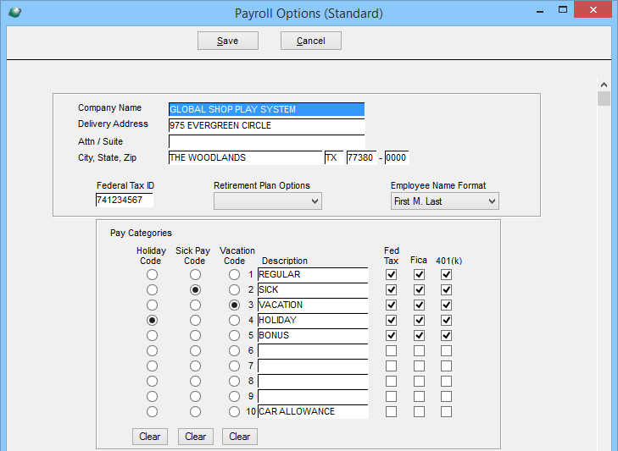

*NOTE: Overtime Multipliers (1.0 or 1.5) are defaulted based on employee grade setup on the employee master.

Design Sample
Sample Input Time File

H,09/23/2005,T,WHJW,WHJW09232005,7,51.00
D,09/23/2005,WHJW09232005,09/19/2005,OEN,48994, ,R1 REGULAR ,T, ,8.00,28582,1315.100333 D,09/23/2005,WHJW09232005,09/19/2005,OEN,48994, ,OVERTIME,T,,10.00,28582, 1315.100333 D,09/23/2005,WHWJ09232005,09/19/2005,OEN,48994, ,HOL,T,,8.00,28582,1315.140103 D,09/23/2005,WHJW09232005,09/19/2005,OEN,48994, ,VAC,T,,8.00,28582,1315.140103 D,09/23/2005,WHJW09232005,09/20/2005,OEN,48994, ,R1 REGULAR,T,,8.00,28582,1315.100333
D,09/23/2005,WHJW09232005,09/20/2005,OEN,48994 ,OT2,T, ,5.00,28582,1315.100333
D,09/23/2005,WHJW09232005,09/23/2005,OEN,48994, ,SICK,T, ,4.00,28582,1315.100333

Schedule/Milestone Overview
Unknown

Testing Requirements Overview
The site will provide an extract from the GSS database and test with Oracle Functional Support Staff and applicable Business owners

Training Requirements or User Documentation Overview
Coordination between GSS and Oracle Technical teams will determine and implement the transmission details for both inbound and outbound file transmissions.

